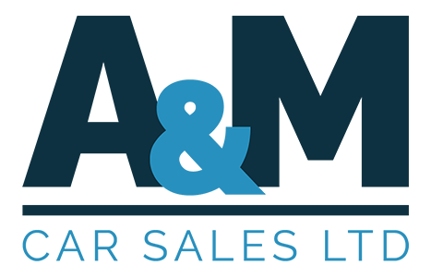
Our Commitment to Quality — The Complaints Procedure
Your views are important to us!
We are committed to respond promptly and fairly to complaints or expressions of dissatisfactions from our customers
Within this leaflet you will find details of our internal customer complaints procedures, including timeframes in which we will respond to any issues that you raise. Our aim is always to satisfactorily resolve any complaint at the earliest opportunity, se please us by following the guidelines in this leaflet. We keep records of all complaints that we receive. They provide us with valuable feedback, tell us how we can improve our services.
Your views are important, so please make them known to us. The complaint investigation is free of charge. Who should you complain to?
In the first instance please address your complaint in writing, email or telephone to our customer services contact. You should already have their details in letters or documents that have been sent to you, but if not, please address your complaint to the Complaints Officer who can be contact on the relevant business address, email or telephone number shown on this leaflet. If you have purchased your vehicle on finance, we will also contact the lender to notify them of your complaint.
What will we do next?
Our aim is to provide a satisfactory solution as speedily as possible. We will endeavour to sort out the problem there and then. In some cases, further investigation may be required, in which case we will try to provide an answer by the end of the next working day following receipt of your complaint. If this is not possible, we will send you a written acknowledgment within five working day of receipt. This will state the name of the person who is dealing with your complaint, their contact details and confirm our understanding of the nature of your concerns.
When will we contact you again?
We will either provide our final response to your complaint within four weeks of receipt, or we will write to you to explain why we have not been able to do so and when we expect to make further contact. If, after eight weeks we have still not provided a final response to your complaint, then we will- write to you giving reasons for the delay and tell you when we expect to be able to provide a final response. If you are able to refer your complaint to an ombudsman service, arbitration scheme, or dispute resolution scheme, then we will explain the process and provide you with the necessary details. Alternatively, you may still choose to wait until we are in a position to provide our final response.
What do we mean by final response?
Our final response will detail the results of our investigation into your complaint and we will explain whether it has been accepted or rejected. In both cases we will explain the reasons for our decision. Where it is appropriate, we may make an offer of redness into account the individual circumstances of each case investigated. This will not always involve financial redness and may simply involve an apology. Our aim is to treat all customers consistently and fairly.
What happens if you remain dissatisfied?
Our final response will provide details of how you may escalate your complaint if you remain dissatisfied following the outcome of our investigation. It will also give you details of any rights of referral you may have to an ombudsman service, arbitration scheme, or dispute resolution scheme.
Contact Details
A&M Car Sales LTD, Cornishway West, Galmington Trading Estate, Taunton, TA1 5NA Tel: 01823 289222. Email: sales@aandmcarsales.co.uk

